Develop an AI agent with Microsoft Foundry Agent Service
- Introduction:
  - Microsoft Foundry Agent Service is a fully managed service designed to empower developers to securely build, deploy, and scale high-quality, extensible AI agents without needing to manage the underlying compute and storage resources.
  - Microsoft Foundry Agent Service offers a solution by allowing you to create AI agents tailored to your needs through custom instructions and advanced tools.
- What is an AI agent
  - An AI agent is a software service that uses generative AI to understand and perform tasks on behalf of a user or another program.
  - Examples of AI agent use cases:
    - Personal productivity agents
    - Research agents
    - Sales agents
    - Developer agents
  - To reduce these risks, developers should adopt a security-by-design approach that includes:
    - Enforcing role-based access controls (RBAC) and least privilege permissions.
    - Adding prompt filtering and validation layers to prevent injection attacks.
    - Sandboxing or gating sensitive operations behind human-in-the-loop approvals.
    - Maintaining comprehensive logging and traceability for all agent actions.
    - Auditing third-party dependencies and integrations regularly.
    - Continuously retraining and validating models to detect data drift or poisoning attempts.
- How to use Microsoft Foundry Agent Service:
  - Microsoft Foundry Agent Service is a fully managed service designed to empower developers to securely build, deploy, and scale high-quality, extensible AI agents without needing to manage the underlying compute and storage resources.
  - Key features of Foundry Agent Service:
    - Automatic tool calling: The service handles the entire tool-calling lifecycle, including running the model, invoking tools, and returning results.
    - Securely managed data: Conversation states are securely managed using threads, eliminating the need for developers to handle this manually.
    - Out-of-the-box tools: The service includes tools for file retrieval, code interpretation, and interaction with data sources like Bing, Azure AI Search, and Azure Functions.
    - Model selection: Developers can choose from various Azure OpenAI models.
    - Enterprise-grade security: The service ensures data privacy and compliance with secure data handling and keyless authentication.
    - Customizable storage solutions: Developers can use either platform-managed storage or bring their own Azure Blob storage for full visibility and control.
  - Basic agent setup: A minimal configuration that includes Azure AI hub, Azure AI project, and Foundry Tools resources.
  - 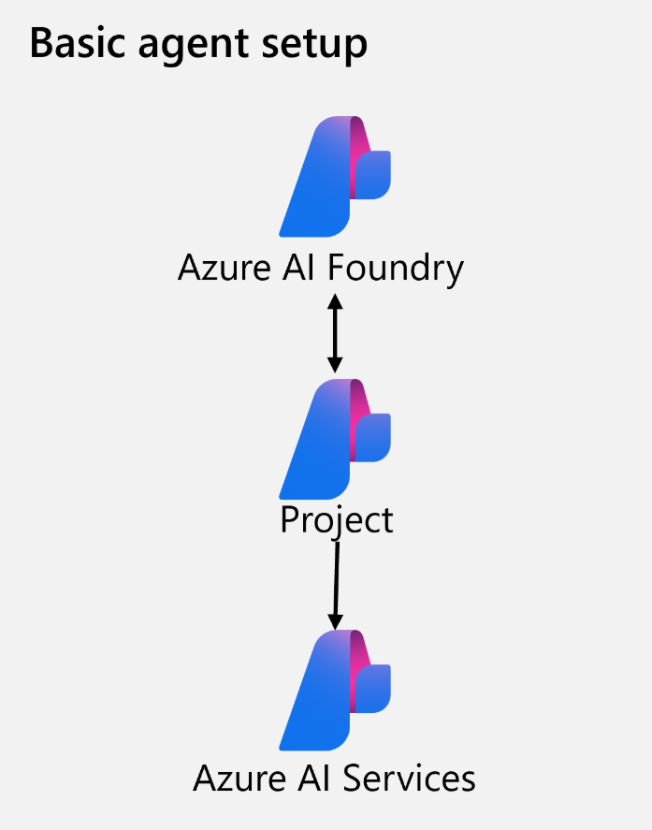

  - Standard agent setup: A more comprehensive configuration that includes the basic agent setup plus Azure Key Vault, Azure AI Search, and Azure Storage.

  - 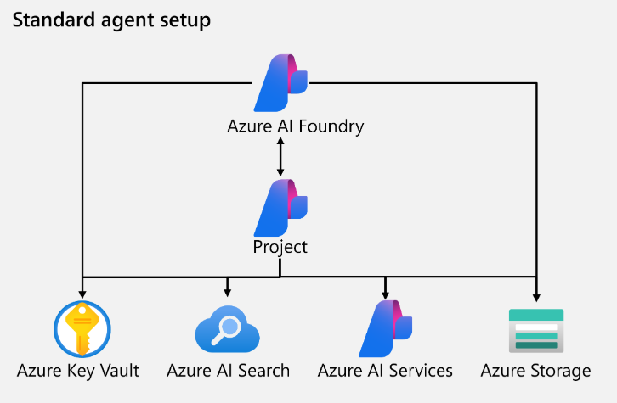

- Develop agents with the Microsoft Foundry Agent Service:
  - Previous solutions to achieve an agent-like experience took hundreds of lines of code to do things like referencing grounding data or connecting to a custom function. The Agent Service now simplifies all of that, supporting client-side function calling with just a few lines of code and connections to Azure Functions or an OpenAPI defined tool.
  - Foundry Agent Service provides several SDKs and a REST API for you to integrate agents into your app using your preferred programming language.
    - Connect to the AI Foundry project for your agent, using the project endpoint and Entra ID authentication.
    - Get a reference to an existing agent that you created in the Microsoft Foundry portal, or create a new one specifying:
      - The model deployment in the project that the agent should use to interpret and respond to prompts.
      - Instructions that determine the functionality and behavior of the agent.
      - Tools and resources that the agent can use to perform tasks.
    - Create a thread for a chat session with the agent. All conversations with an agent are conducted on a stateful thread that retains message history and data artifacts generated during the chat.
    - Add messages to the thread and invoke it with the agent.
    - Check the thread status, and when ready, retrieve the messages and data artifacts.
    - Repeat the previous two steps as a chat loop until the conversation can be concluded.
    - When finished, delete the agent and the thread to clean up the resources and delete data that is no longer required.
  - You can assign tools when creating an agent in the Microsoft Foundry portal, or when defining an agent in code using the SDK.
  - 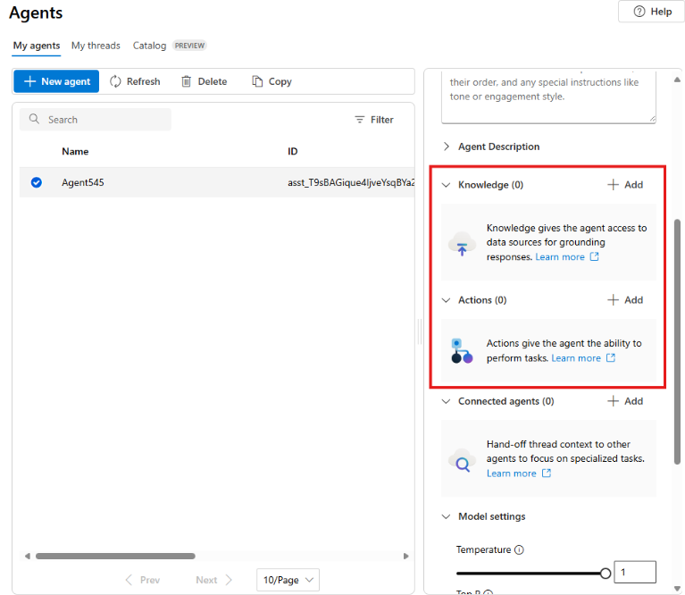
  - Knowledge tools enhance the context or knowledge of your agent. Available tools include:
    - Bing Search: Uses Bing search results to ground prompts with real-time live data from the web.
    - File search: Grounds prompts with data from files in a vector store.
    - Azure AI Search: Grounds prompts with data from Azure AI Search query results.
    - Microsoft Fabric: Uses the Fabric Data Agent to ground prompts with data from your Fabric data stores.
  - Action tools perform an action or run a function. Available tools include:
    - Code Interpreter: A sandbox for model-generated Python code that can access and process uploaded files.
    - Custom function: Call your custom function code – you must provide function definitions and implementations.
    - Azure Function: Call code in serverless Azure Functions.
    - OpenAPI Spec: Call external APIs based on the OpenAPI 3.0 spec.
  - Exercise: https://microsoftlearning.github.io/mslearn-ai-agents/Instructions/02-build-ai-agent.html
  - 